**Sprint 3 - Agility Design Document**

**April 20, 2023**

**Table of Contents**

**1.** **EXECUTIVE SUMMARY**

1.1 Project Overview

**2.** **PRODUCT/SERVICE DESCRIPTION**

2.1 Product Context

2.2 User Characteristics

2.3 Assumptions

2.4 Constraints

2.5 Dependencies

**3.** **REQUIREMENTS**

3.1 Functional Requirements

**4.** **REQUIREMENTS CONFIRMATION/STAKEHOLDER SIGN-OFF**

**5.** **SYSTEM DESIGN**

5.1 Algorithm

5.2 System Flow

5.3 Program Code

5.4 Program SENSORY Data

5.5 Test Plan

5.6 Task List/Gantt Chart

5.7 Staffing Plan

1. Executive Summary

***1.1*** ***Project Overview***

Your robot will run the obstacle course. The course will start in a square. Then the

robot will encounter 3 objects which it must avoid. Next, the robot will go over the ramp.

Finally, the robot will knock over as many pins as possible. Points are added for each obstacle the robot completes, for each obstacle avoided, and, for each pin, the robot topples.

2. Product/Service Description

In this section, describe the general factors that affect the product and its requirements. This section should contain background information, not state specific requirements (provide the reasons why certain specific requirements are later specified).

***2.1*** ***Product Context***

This product is part of a three-part series. This first part is to show a basic understanding of the material and to express any concerns about the material.

***2.2*** ***User Characteristics***

· Student/faculty/staff/other

· Experience

· Technical expertise

***2.3*** ***Assumptions***

* Need basic training in working with robots
* Need spacial awareness
* Availability to technology

***2.4*** ***Constraints***

· System resource constraints

· Availability of team members

· Time to complete the project

***2.5*** ***Dependencies***

· Device must be able to run the program

· Availability of both team members

3. Requirements

**Priority Definitions**

· Priority 1 – Technology and education required to complete the process. Time Management to complete the project on time.

· Priority 2 – Ability to code and fulfill all requirements.

·Priority 3- User-friendly materials, and little to no experience friendly

***3.1*** ***Functional Requirements***

| **Req#** | **Requirement** | **Comments** | **Priority** | **Date Rvwd** | **SME Reviewed / Approved** |
| --- | --- | --- | --- | --- | --- |
| Agility_01 | Navigate the around the bottles | Create a program to navigate around the three bottles | 1 | 4/18/23 | Approved |
| Agility_02 | Navigate the jump | Create a program to have the robot go over the jump | 2 | 4/18/23 | Approved |
| Agility_03 | Knockdown markers | Create a program to have the robot knockdown markers | 3 | 4/18/23 | Approved |

4. Requirements Confirmation/Stakeholder sign-off (Gillian provided the information for this section)

Include documentation of the approval or confirmation of the requirements here.

| **Meeting Date** | **Attendees (name and role)** | **Comments** |
| --- | --- | --- |
| 04/18/23 | Vaughn | confirmed |
| 04/18/23 | Gillian | confirmed |

5. System Design

***5.1*** ***Algorithm***

* Start Program
* Navigate around the first bottle
* Navigate around the second bottle
* Navigate around the third bottle
* Navigate over the jump
* Knockdown as many markers as possible
* End program

***5.2*** ***System Flowchart (Gillian provided the information for this section)***

Develop a flowchart (and show here) that accurately depicts how your software application will act to fulfill the algorithm

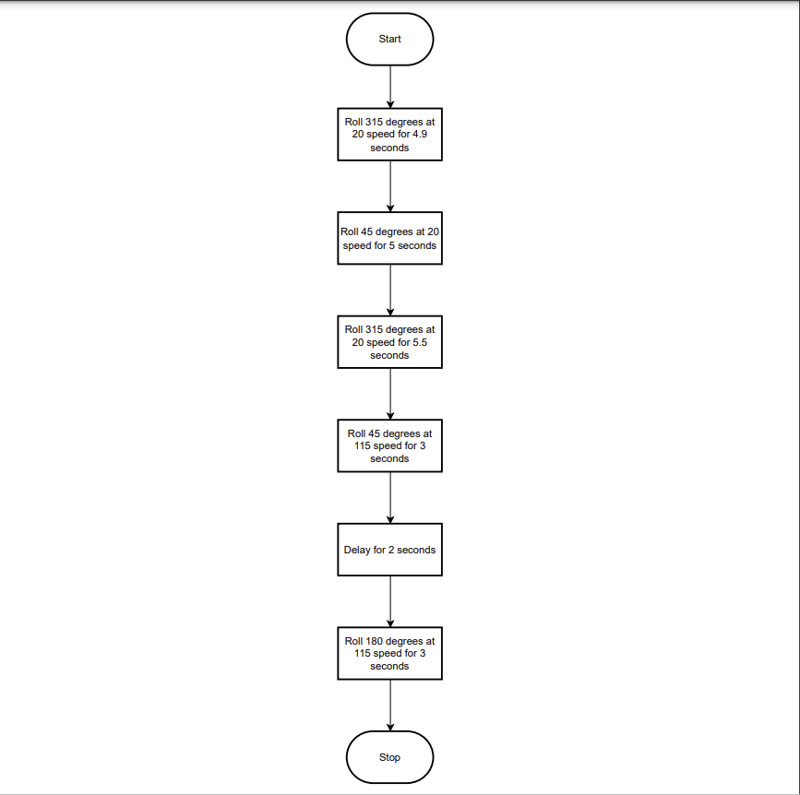

***5.3*** ***Program Code***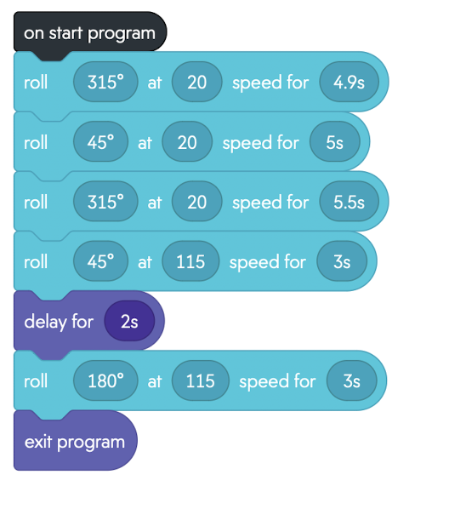

***5.4*** ***Program Sensory Data***

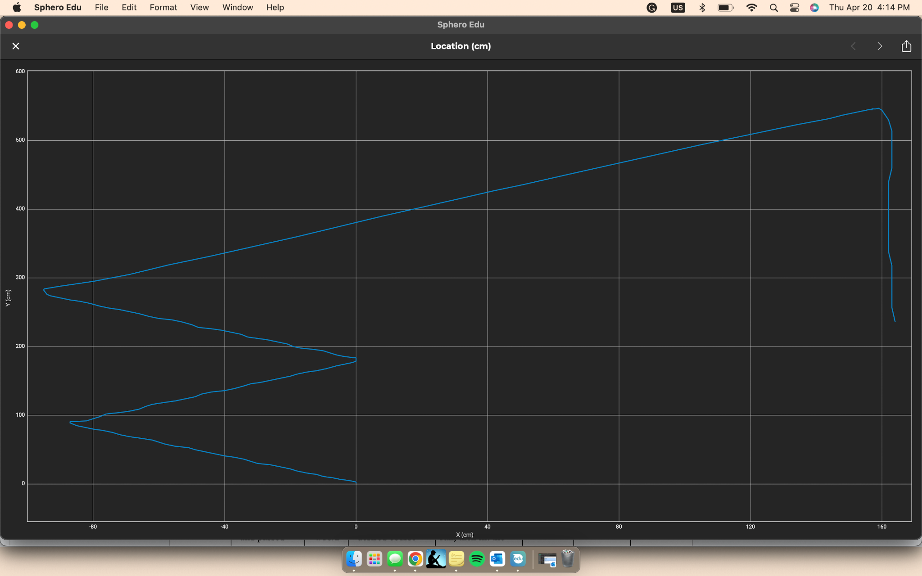

***5.5*** ***Test Plan***

| **Reason for Test Case** | **Test Date** | **Expected Output** | **Observed Output** | **Staff Name** | **Pass/Fail** |
| --- | --- | --- | --- | --- | --- |
| Navigate to first obstacle | 4/18/23 | Performs the desired course | Ran into object | Vaughn | Fail |
| Navigate to first object | 4/18/23 | Performs the desired course | Performed desired task | Vaughn | Pass |
| Navigate to and passed first object | 4/18/23 | Performs the desired course | Performed first run, then hit the obstacle | Vaughn | Fail |
| Navigate to and passed first object | 4/18/23 | Performs the desired course | Performed desired task | Vaughn | Pass |
| Navigate second and third obstacle | 4/18/23 | Performs the desired course | Performed desired task | Vaughn | Pass |
| Naviagte all obstacles, go over the ramp | 4/18/23 | Performs the desired course | Did not get up ramp | Vaughn | Fail |
| Go over the ramp | 4/18/23 | Performs the desired course | Did not accomplish task | Vaughn | Fail |
| Go over ramp | 4/18/23 | Performs the desired course | Performs the desired course | Vaughn | Pass |
| Navigate all obstacles and go over ramp | 4/18/23 | Performs the desired course | Performed the desired task | Vaughn | Passs |
| Navigate the course and knockdown all pins | 4/20/23 | Perform desired course and knockdown all pins | Performed desired task | Vaughn | Pass |

***5.6*** ***Task List/Gantt Chart***

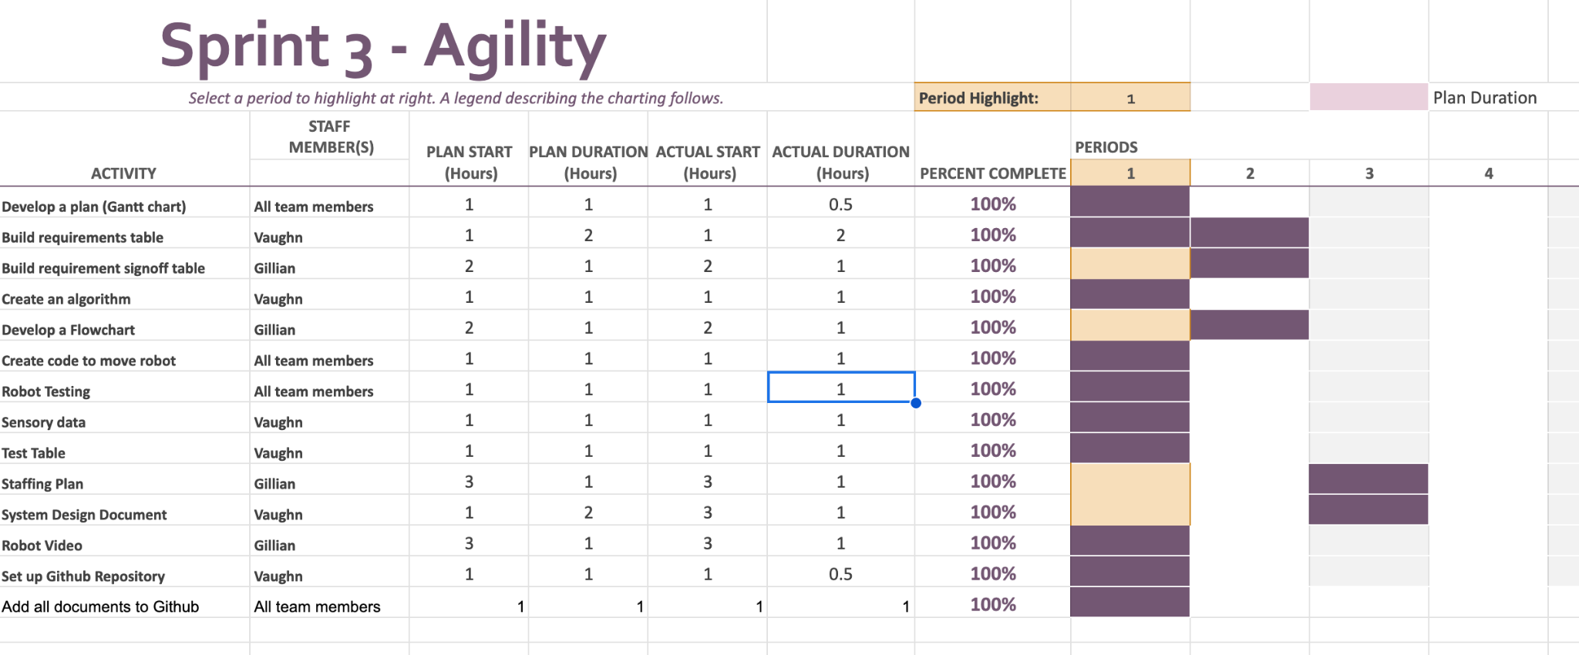

***5.7*** ***Staffing Plan (Gillian provided the information for this section)***

Insert a chart/table that depicts the roles and responsibilities of each team member that worked on this project

| Name | Role | Responsibility | Reports To |
| --- | --- | --- | --- |
| Vaughn/Gillian | Develop a plan (Gantt chart) | Develop a plan (Gantt chart) | Vaughn/Gillian |
| Vaughn | Build requirements table | Build requirements table | Vaughn/Gillian |
| Gillian | Build requirement signoff table | Build requirement signoff table | Vaughn/Gillian |
| Vaughn | Create an algorithm | Create an algorithm | Vaughn/Gillian |
| Gillian | Develop a Flowchart | Develop a Flowchart | Vaughn/Gillian |
| Vaughn/Gillian | Create code to move robot | Create code to move robot | Vaughn/Gillian |
| Vaughn/Gillian | Robot Testing | Ensure that the robot follows the code as created | Vaughn/Gillian |
| Vaughn | Sensory data | Sensory data | Vaughn/Gillian |
| Vaughn | Test Table | Test Table | Vaughn/Gillian |
| Gillian | Staffing Plan | Staffing Plan | Vaughn/Gillian |
| Gillian | Robot Video | Robot Video | Vaughn/Gillian |
| Vaughn | Set up Github Repository | Set up Github Repository | Vaughn/Gillian |
| Vaughn/Gillian | Add all documents to Github | Add all documents to Github | Vaughn/Gillian |